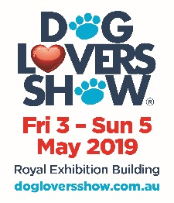
2019 MELBOURNE DOG LOVERS SHOW
ANIMAL MANAGEMENT PLAN (AMP) FOR DOGA PARTICIPANTS
(Revised February 2019)

The Dog Lovers Show (DLS) places animal welfare and the safe interaction of dogs and people as its highest priority.
This Animal Management Plan (AMP) has been prepared to ensure the highest level of welfare is provided for all dogs that are presented and cared for on-site during the show, and in what is a unique environment. The conditions outlined in this AMP are applicable to any persons or company bringing dogs to the show including but not limited to all Participants.

Dog Lovers Show Pty Ltd (DLS) as the Organiser of the Dog Lovers Show, along with Museum Spaces, managers of the
Royal Exhibition Building, are committed to providing an environment that is safe and healthy for the venue and event staff, contractors, members of the public and in particular event exhibitors and their animals.

All persons and dogs are required to comply with the Prevention of Cruelty to Animals Act 1986 and the Prevention of Cruelty to Animals Regulations 2008, The Domestic Animals Act 1994 and the Domestic Animals Regulations 2015, and the Victorian Codes of Practice for Animal Welfare made under those Acts.

The local government council is Melbourne City Council and the relevant legislation they administer is the Domestic Animals Act 1986 and the Regulations 2008. The council publishes their requirements on their website and they can be found here https://www.melbourne.vic.gov.au/residents/pets/Pages/domestic-animal-management-plan.aspx

All participants bringing a dog into the venue/show have an obligation to familiarise themselves and comply with all of the above legislations and advisories.

The Organisers do not accept any responsibility for any loss or damage, financial or otherwise, resulting from any incident (including injury to persons or animals) arising from any animal interactions during the Dog Lovers Show.

A person who brings any dog into the venue/show is the “competent person in effective control” of the animal, and this person holds the relevant duty of care for their dog(s) and to the community. This includes, but is not limited to the control, comfort, safety and welfare of their animal and the interaction of any animal under their control, and with any other person or animal, at any time, whilst on-site at the Dog Lovers Show.

For the purpose of this AMP, all dogs are treated equally regardless of size or breed. Consequently the burden of care is placed upon the competent person in effective control for the control, comfort, safety and welfare of their animal and DLS has prepared this Animal Management Plan to assist exhibitors in contributing to an enjoyable environment where both exhibitors and the public can celebrate their love of dogs in a safe and positive environment.

It is a mandatory requirement that all participants who are bringing dogs to the show, must read, fully understand and agree to this Animal Management Plan or entry will be refused. DLS will be uncompromising in enforcing the conditions and rules outlined in this Dog Lovers Show Animal Management Plan.

- Making the right decision about having your dog involved
The Dog Lovers Show can be a very busy, noisy, stressful and demanding environment for animals. Are you very confident that your particular dog will cope? It is a mandatory requirement that any dog brought into the Dog Lovers Show is in peak condition (physical and mental) and good health.

Large crowds, continual loud noise, constant audio-visual demonstrations, repetitive stranger interaction, along with the presence of hundreds of other dogs is an incredibly stressful and unprecedented environment for most dogs and the majority will not be used to handling this sort of pressure. If your dog does not cope in stressful situations or you do not know if the dog you are bringing to the show is capable of coping, it must not attend.

Just because your dog is happy within its normal ‘comfort zone’ environment at home, local dog parks, smaller events etc, that does not mean they will react the same way at the Dog Lovers Show.
For example many dogs have difficulty dealing with stressful situations like fireworks, thunderstorms, huge crowds and un-invited visitors. If your dog has problems with any of these conditions in their known environment, you can be confident that they are not able to handle the stress presented by spending three days at one of the biggest dog shows in the world. And the majority of the time you will be too busy to effectively monitor their well-being.

First and foremost, you must consider your dog’s welfare and the welfare of the staff and visitors your dog may interact with and put that consideration ahead of your desire to have a dog on your stand. If there is any doubt whatsoever please do not bring the dog(s) to the Show.

General Control
DLS will have Animal Welfare Officers patrolling the show at all times to monitor the condition of all dogs on-site and to ensure that all conditions of the Animal Management Plan are always being adhered to.
DLS reserves the right and full authority to demand the immediate removal of any dog from the show if it considers that the dog is showing any ongoing signs of stress or believed to be suffering any negative effects from its presence at the show.
All participants must immediately comply with any warning or direction given by Animal Welfare Officers, DLS management, security personnel or other authorised DLS representative. Documented warnings or directions may be issued if deemed necessary and non-compliance with any written warning or direction will result in a demand to remove the dog from the show.

All participants bringing dogs to the show should have contingency plans in place to allow for the removal of their dog. This means not having to leave your stand unattended during the removal, having a second person to take the dog home or having someone on call to collect your dog.

Removal from the show does not include taking your dog outside and leaving it tied up or locked in your vehicle – it means taking your dog home.
Any dog found unattended in a vehicle will be immediately reported to the Melbourne City Council, Venue Security, the RSPCA Inspectorate and the Victoria Police.

Risk Management and Keeping the Show Safe
During the Dog Lovers Show, the competent person in effective control holds absolute responsibility for the control of their animal, and must take all possible actions to minimise any risks associated with having a dog at the Show.
DLS has set the following rules as the minimum conditions that must be maintained at all times when on-site (including pre and post opening hours).

  - On any stand where a dog(s) is present, it is mandatory that a minimum of two people are present on the stand at all times and that one person is designated as the competent person in effective control. Participants who are to be identified as the competent person in effective control must notify DLS staff at the information desk on immediate arrival at the show so you can be provided with a form of identification for you and your dog.

  - All animals on stands are to remain under direct supervision at all times and must be restrained by a collar (or harness) and lead at all times and are limited to no more than two dogs per competent person in effective control.

  - At no time may a dog be left unattended on any stand even if the dog is restrained.

  - Unless a dog’s lead is being hand held, your dog’s leads must be secured to a suitable fixed anchor point and not a movable object. Under no circumstances is a dog ever to be left free to roam or unsecured on your stand.

  - All dogs can be territorial or possessive of toys and food and sometimes react aggressively or defensively to protect their possessions. For this reason allowing dogs to have play or chew toys, bones or providing bowl feeding is not allowed on any stand, unless the dog has been isolated from public interaction.

  - It is your responsibility to schedule regular breaks for your dog to be physically removed from the venue for rest, relief and downtime. There is ample space in Carlton Gardens for this purpose and it is your responsibility to abide by all laws and regulations relating to dogs within Carlton Gardens so please take note of all signage and regulations posted within the park.

  - All dogs must be provided with easy access to fresh drinking water and it is your responsibility to ensure this is regularly replenished so dogs are kept well hydrated.

The Dog Lovers Show recognises its obligations under the following Acts:

Disability Discrimination Act 1992 (Commonwealth)
New South Wales – Anti-Discrimination Act 1977

In recognising DLS obligations under these Acts DLS has made reasonable adjustments to ensure access to people with accredited assistance dogs are able to work and participate at each of its events.

These reasonable adjustments are made within the context of DLS’s obligations in providing a workplace that is free of risk to the health and safety of workers, exhibitor and visitors under the applicable WHS/OH&S Acts and Regulations in each state.

They ensure we meet our obligations of consultation, reasonable adjustment and the provision of a site that is free of risk to health and safety we require exhibitors, or their staff or any volunteers with assistance animals to register and provide their assistance animal accreditation prior to attendance during both the bump in and bump out period of the show.

Should you wish to discuss this with a DLS Representative, please contact Trudi Borin at trudi@eventmi.com.au

Incident reporting:
Any observed, uncharacteristic aggression, rushing or snapping will be treated as an incident (near miss) and you will be directed to immediately remove your dog from the venue. Not withstanding this removal, if a third party (public or staff member) has been affected, in any way by the incident, they may exercise their rights and report the incident to the Melbourne City Council via phone on (03) 9658 9658.
You will be required to assist any third parties in the exercise of their rights.

The competent person in effective control will be required to provide the following information to the Melbourne City Council:
- time and date of the incident
- where it happened
- name of the dog owner
- dog registration number
- a description of the dog
- a detailed description of the incident

Any incident that results in an injury requiring medical treatment as defined under the Occupational Health and Safety Act 2004 (Vic), Part 5, Duties Relating to Incidents, will be treated as a reportable injury and advised to WorkSafe (Victoria). This will be done immediately via telephone and then in writing within 48 hours of the incident and you will be required to assist in the completion of an Incident/Injury Report available from the organiser. You may also have a duty under to preserve the incident site. This would be confirmed as a requirement, or not, as a result of immediate phone consultation with WorkSafe. Any third party will be advised of their rights immediately.

In the case of a reportable injury the Melbourne City Council will also be notified and you may be considered guilty of an offence under the Domestic Animals Act 1986.

Canine Body Language

It is essential that you visually monitor your dog and “listen” to what they are telling you. Following are some common behaviour and what they look like but remember your dog is a unique individual and may not display all of these traits. But you can use this information to get an idea of what to look for in your dog and what feelings they are displaying to you.

AGGRESSIVE  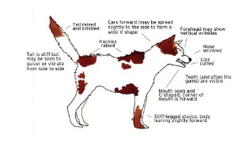 | Ears - Back, close to head  Eyes - Narrow or staring challengingly.  Mouth/teeth - Lips open, drawn back to expose teeth bared in a snarl. Possible jaw snapping. Body - Tense. Upright. Hackles on neck up. Completely dominate position.  Tail Straight out from body. Fluffed up. Vocalization - Snarl. Growl. Loud bark.
ALERT  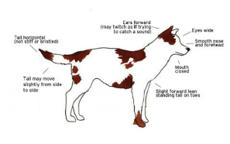 | Ears - Perked-up. Turning to catch sounds. Eyes - Open normally or wide.  Mouth/teeth - Mouth closed or slightly open with teeth covered.  Body - Normal. Possible standing on tiptoe. Slightly dominant position. Tail - Up. Possibly wagging.  Vocalisation - None. Low whine or alarm bark.
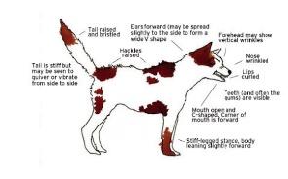  DOMINANT | Ears - Up straight or forward  Eyes - Wide open, staring, direct contact. Mouth/teeth - Mouth closed or slightly open.  Body - Very tall posture. May drape head over another dog's shoulders. Hackles may be up. Tail - Stiffened and fluffed. Up or straight out from body.  Vocalisation - Low, assertive growl or grunt.
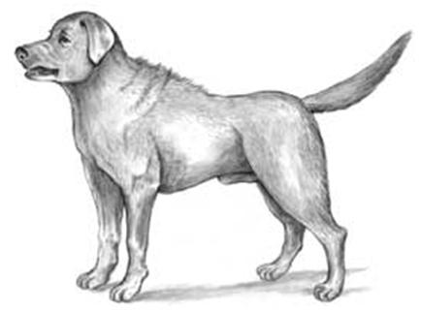  GUARDING | Ears - Perked up. Forward. Eyes - Wide open, alert.  Mouth/teeth - Mouth slightly open, teeth bared. Snapping or gnashing of teeth.  Body - Tense. Rigid. Hackles up. Standing very tall in an aggressive or dominant stance. Tail - Rigid. Held straight out from body. Sometimes fluffed.  Vocalisation - Loud, alert bark. Growl. Snarl.
FEARFUL  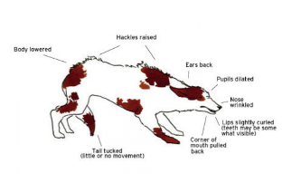 | Ears - Laid back flat and low on head.  Eyes - Narrowed, averted. Possibly rolled back in head, whites showing, dilated pupils. Mouth/teeth - Lips drawn back to expose teeth.  Body - Tense. Crouched low in submissive position. Shivering, trembling. Frozen in one place. Tail - Down between legs.  Vocalisation - Low, worried yelp, whine or growl.
PLAYFUL/HAPPY  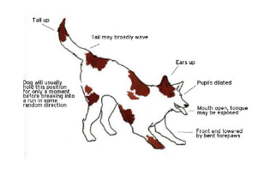 | Ears - Perked up and forward or relaxed. Eyes - Wide open.  Mouth/teeth - Relaxed and slightly open, teeth covered. Excited panting.  Body - Relaxed, or front end lowered, rear end up in the air, wiggling in a play bow. Excited bouncing or jumping up and down. Circling around and forward as an invitation to play.  Tail - Wagging vigorously.  Vocalisation - Excited barking. Soft play growling.
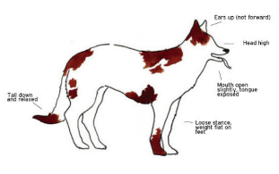  RELAXED/FRIENDLY | Ears - Perked up.  Eyes - Wide open. Alert look.  Mouth/teeth - Relaxed, possibly slightly open, "smiling" mouth. Body - Normal. Still or possible wiggling of whole rear end.  Tail - Up or out from body. Wagging.  Vocalisation - Whimpering, yapping, or short, high bark.

Dog-to-Dog interaction
With the large number of dogs at the show and an extensive range of breeds present, dog-to-dog aggression is a possibility. In order to ensure the safety and welfare of all animals participating at the Show, all participants must ensure their dog is suitably controlled when approaching or being approached, by any other dog.

Always ask for permission from other dog handlers before allowing your dog to approach any other dog.

Health and protection
To ensure the direct safety of all exhibitor dogs, other dogs participating in the show, staff and members of the public attending the show, all exhibitors are required to confirm that prior to entry to the event, their dog has received all recommended vaccinations and we advise all exhibitors to ensure there dog has received recent worming and flea treatments as per treatment manufactures guidelines.
Female dog’s that are in season or expecting to come into season are not to be brought into the venue or show under any circumstances and should a dog unexpectedly come into season during the show then the dog must be removed from the venue immediately.

Toileting and doggy time out
It is a requirement of participation at the Dog Lovers Show that all dogs are fully toilet trained.
Dog access doors have been allocated for the exclusive use of exhibitors with dogs. The doors are located at Door 2B (Nicholson St) and door 8A (Rathdowne Street) - please refer to the floor plan or ask at the information desk for directions.
The dog access doors allow participants to take dogs out for toileting and time out from the show. Participants must wear their passes (eg exhibitor or presenter pass) when exiting the building to ensure re-entry.
Dogs should be walked into Carlton Gardens for toileting and under no conditions should dogs be allowed to toilet near the venue or surrounding areas. Participants are responsible for the provision and removal of their own bags to clean up dog waste.
If an animal relieves itself within the building, the exhibitor is required to secure the immediate area for slip or biohazard and contact the event organiser, info desk, security or cleaning staff immediately.
In the interest of comfort and welfare of the dogs, exhibitors are encouraged to regularly exercise their dogs and provide toilet breaks for them during the event and to monitor their animals for signs of boredom, restlessness or listlessness. Please ensure you have adequate staff numbers on your stand to rest and relieve your dog(s) and ensure your stand is staffed at all times.

Feeding and Hydration
With dogs on-site for the duration of the show, exhibitors are required to provide all the food and water required for their dogs at the event and make suitable preparation for storage.
Remember, all dogs can be territorial or possessive of toys and food, and react aggressively or defensively to protect their possessions. For this reason, allowing dogs to have play or chew toys, bones or providing bowl feeding, is not allowed on any stand, unless the dog has been isolated from public interaction.
Participants are encouraged to feed their dog in small, regular servings, so that unattended food does not cause unwanted interaction from other dogs at the event. All foods are to be stored in sealed containers at all times.
Take great care to ensure your dog remains well hydrated, and help avoid the possibility of heat stress. Water will be available within the venue for you to fill containers and bowls. Exhibitors are required to provide a water bowl on their stand for the dogs’ welfare, but must place the bowl where it will not present a trip hazard or be in danger of coming into contact with live electrical equipment.

Veterinary support
DLS has arranged for a veterinary surgeon to be on duty during show open hours. The scope of duties of the veterinary surgeon will include emergency assistance and dog first aid, in addition to providing oversight and direction relating to animal welfare, including directing exhibitors to remove dogs if deemed necessary.

Animal Evacuation
In the event of an incident that requires emergency evacuation from either building, all exhibitors, contractors, event staff, members of the public and other persons shall follow the directives of the appointed emergency evacuation wardens and proceed to the nominated emergency evacuation point and await further instruction.

Participants should consider the welfare and safety of their animal during an emergency evacuation event.
All animals shall be under the direct supervision and restraint of the competent person in effective control, at all times. Consideration should be made to whether animal carriers or crates are required for animal evacuation. Storage and use of such items must be kept within your stand’s footprint, not block emergency aisle ways or pose obstruction to persons exiting the building for the purposes of emergency evacuation.

Dog Registration
It is a condition of participation that all dogs must be currently registered and wearing their council issued identification tag as per the Domestic Animals Act 1986 Companion Animals Act 1998 and local council regulations.

Should you have any queries or wish to discuss any part of the Animal Management Plan, please contact Faith Gasparini at the
Dog Lovers Show office:
  - Tel: (03) 9696 9961
  - Email: faith@eventmi.com.au

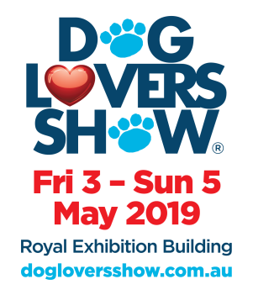
Your agreement and commitment to the Animal Management Plan

All Exhibitors/Sponsors/Participants bringing a dog into the show must complete and return this page and by doing so it confirms that you have read, understood and will abide by all conditions of the Animal Management Plan (AMP). It also confirms that you are responsible for any and all dog/s that you intend to exhibit as part of the Dog Lovers Show.

You also agree to abide by any and all warnings and directions given directly or via signage and announcements posted by DLS or its representatives, Museum Spaces, authorised event staff, security personnel, and other authorised staff, and/or their appointed officers in the interests of maintaining animal welfare, public safety and occupational health and safety, and accept that failure to comply to these and other legislative requirements may result in the demand for removal of dog/s from site, and/or being reported to relevant authorities.

All persons bringing dogs into the event must remain fully compliant with every condition of the AMP at all times. It is your responsibility to ensure that all staff on your stand are aware of and comply with the entire Animal Management Plan and to ensure that they have read and understand their obligations and responsibilities during the show.

By signing below, I ……………………………………………… acknowledge that I have read and agree to all the terms, conditions and regulations stated in the Dog Lovers Show Animal Management Plan for Participants.

Participant name………………………………………………………………………………………..

Stage/Area: RACV Pet Insurance Stage – DOGA Session

Name of nominated competent person(s) in effective control:

………………………………………………………………………………………………………………………………………

Signed…………………………………………………………… Date……………………

Signed agreements (only this last page is needed) must be returned to DLS by 14th April 2019.
Return the AMP via:

  - Scan or photograph and email to: faith@eventmi.com.au
  - Mail to: 1/192 Bridport Street, Albert Park, Victoria 3206

